**Objectives:**

* Oracle SQL
* Column Alias names
* Arithmetic Operations
* Using the distinct and unique clause
* Using the concatenation to bind

**Note: be sure to print screen your SQL script with the output for each question. There are 9 questions each worth 11.1%**

1. **Selecting one column from a Table:**



**#1 print screen the SQL Statement with any output below here.**

1. **Selecting multiple columns from a table:**



**#2 print screen the SQL Statement with any output below here.**

1. **Using Column Aliases:**  are used for temporary column names.

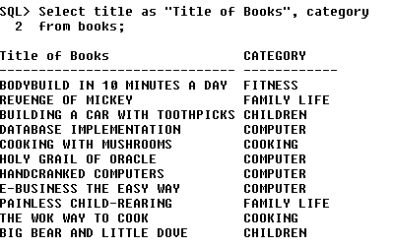

**#3 print screen the SQL Statement with any output below here.**

1. **Using arithmetic operations:** the example below subtracts the retail and cost.

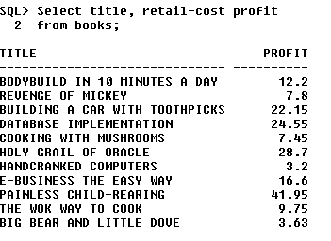

**#4 print screen the SQL Statement with any output below here.**

1. **Using Distinct:** the distinct is used to filter out duplications.

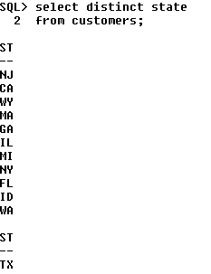

**#5 print screen the SQL Statement with any output below here.**

1. **Using Unique:** the unique is used to filter out duplications.

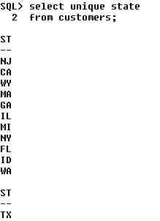

**#6 print screen the SQL Statement with any output below here.**

1. **Using concatenation:** concatenation is used to place two or more strings together.

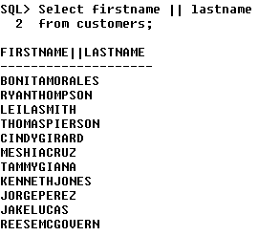

**#7 print screen the SQL Statement with any output below here.**

1. **Using the concatenation and placing a space between strings:** note that you have to place a space between the single quotes.

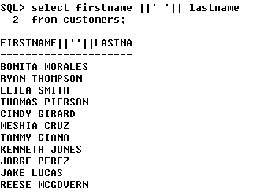

**#8 print screen the SQL Statement with any output below here.**

1. **Using column aliases for concatenated values:**

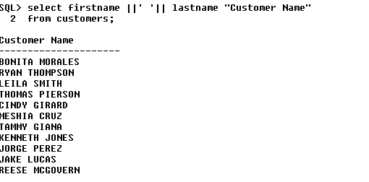

**#9 print screen the SQL Statement with any output below here.**

**Submit this document to Module 2 Class Exercise #2**